Cheatsheets
The National Center on Disability and Access to Education
NCDAE
http://ncdae.org/resources/cheatsheets/

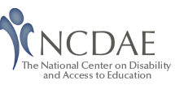These one-page accessibility resources, or “cheatsheets,” have been developed to assist anyone who is creating accessible content. These free resources are catered to less-technical individuals, such as faculty and staff.
- Microsoft Office
  - Word
  - PDF Conversion in Word
  - PowerPoint
  - Excel
- Adobe
  - Acrobat XI
  - Acrobat X
  - InDesign CS5.5
- Other Accessibility Topics
  - Creating Accessible Electronic Content
  - Identifying Web Accessibility Issues
  - Captioning YouTube Videos

