Microsoft PowerPoint 2013 (Windows)
The National Center on Disability and Access to Education
NCDAE

http://ncdae.org/resources/cheatsheets/powerpoint2013.php

Creating Accessible Microsoft PowerPoint 2013 Presentations (Windows)

Slide Layouts
Using slide layouts provided within PowerPoint will ensure files have correctly structured headings and lists, and proper reading order.
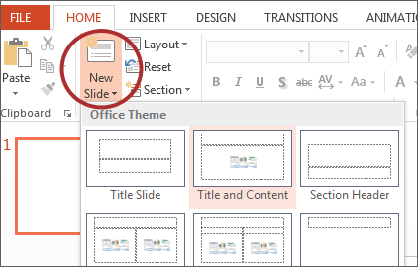

Creating Slide Layouts
- Select Home > New Slide.
- Choose the desired layout from the Layout option.

Alternative Text for Images
Images can be given appropriate alternative text in PowerPoint. This Alt text is read by a screen reader in a PowerPoint file and should remain intact when exporting to HTML or PDF.
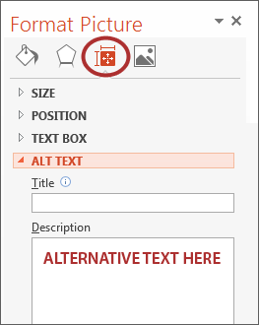

Adding Alt Text
- Right-click on the image and choose Format Picture.
- Select the Size & Properties icon and choose Alt Text.
- Enter appropriate Alt text only in the Description field (not the Title field).

Data Tables
Accessible tables need a clear table structure and table headers to help guide a screen reader user.
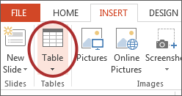
- Select the Insert tab on the ribbon, then select Table > Insert Table.
- PowerPoint can style rows and columns so they appear as data tables, but there is no way to add table header information in a way that will be identified by a screen reader.
- If your presentation contains more than the simplest tables, and if you have Adobe Acrobat, consider saving your presentation to PDF and adding the additional accessibility information in Acrobat Pro.

Links
PowerPoint automatically creates a hyperlink when a user pastes a full URL onto a page. These may not make sense to screen reader users, so more information is needed.
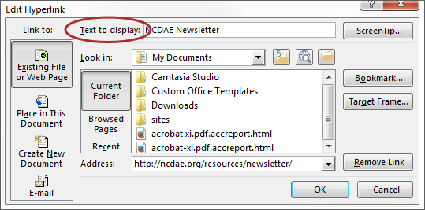

Editing Hyperlinks
- Select a hyperlink, right click, and select Edit Hyperlink or Ctrl + k.
- Change the text in the Text to Display field to a more meaningful description.

Outline and Notes Panels
PowerPoint contains two panels that can be used to enhance accessibility: the Outline panel and the Notes panel.

Outline Panel
- The Outline panel, found under View > Outline View, contains a text outline of the content that appears in your slides.
- Reviewing this panel can help ensure the content on the slides is logically sequenced, that slide titles are unique and meaningful, and that reading order is appropriate for any user.

Notes Panel
- The Notes panel, found under View > Notes, allows the speaker to add notes and information that will not appear on the slides. This information may not be accessed by a screen reader, so do not put important information in this area.

Accessibility Checker
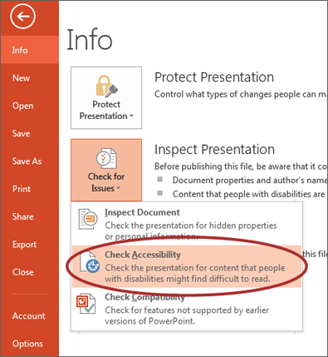
PowerPoint includes an accessibility resource that identifies accessibility issues.
- Select File > Info.
- Select the Check for Issues button and choose Check Accessibility.
- The Accessibility Checker task pane will show accessibility errors, warnings, and tips on how to repair the errors. Select specific issues to see Additional Information at the bottom of the task pane.

Other Principles
- Ensure font size is sufficient. If your presentation will be viewed on a projector, font size may need to be even larger.
- Provide sufficient contrast. If your presentation will be viewed on a projector, sometimes the contrast needs to be even more pronounced.
- Do not use color as the only way to convey content.
- Avoid automatic slide transitions.
- Use simple slide transitions when possible.
- Check reading order of text boxes that are not part of the native slide layout. They are usually the last thing read by a screen reader.
- If you have embedded video, ensure the video is captioned.
- If you have embedded audio, include a transcript.
- If your slides contain animations, ensure they are brief and do not distract from the most important content on the page.
- Use simple language.

